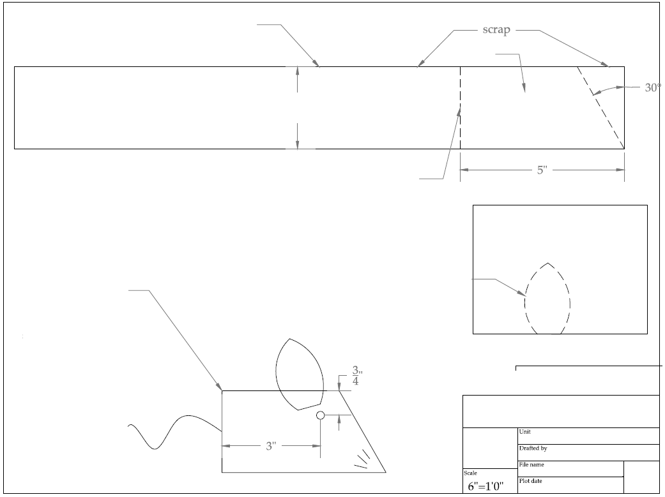

Kelly The Safety Mouse

9/12/2019

Brian Ketcham

Drill a hole for the eye, attach the ear with a screw or staple, same for a string for the tail. 6” is a good length. You can do staples for the whiskers, or you can haver the kids just draw them on and attach the pieces with screws

Scrap Lauan, this is the easiest shape layout, use the edge as the bottom of the ear and use a jigsaw to cut the 2 curves to meet at a point.

With boards 10” of longer, I have the kids cut the angle first, while the board is long, then cut the straight 5” from the point, and if they hold onto the off cut rather than onto the mouse for the straight cut because I want them to hold their hands further away from the blade. If you have a band saw you can have them add a slight curve to the mouse’s butt.

You can use 1x4, 2x3, 1x4 or 2x4 boards. We always have 2x4 scrap at KHS, so that is what we used.

3 ½”